Create the Database (using mongosh, take screenshot)

- Create the 5 collections (using mongosh, take screenshot)

- Create a document in one of the collections using insertOne() (using mongosh, take screenshot)

- Create 2 documents in one of the collection using insertMany() (using mongosh, take screenshot)

Populate all the collections with atleast 10 documents each (using mongosh, take screenshot)

- Update 1 document using updateOne() command - (using mongosh, take screenshot)

- Update multiple documents using updateMany() command - (using mongosh, take screenshot)

- Read one document using findOne() command - (using mongosh, take screenshot)

- Read multiple documents using find() command (using mongosh, take screenshot)

- Delete one document using deleteOne() (using mongosh, take screenshot)

- delete multiple documents using deleteMany() (using mongosh, take screenshot)

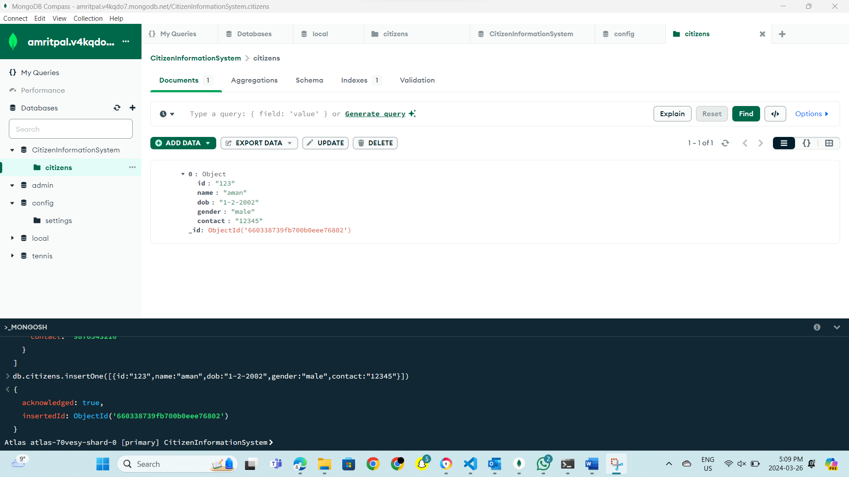

In this I have created the database according to my project and I have given the database name to it that is: - Citizeninformationsystem, furthermore I created a collection named citizens . Moreover, I inserted one document using insert One.

- Create 2 documents in one of the collection using insertMany() (using mongosh, take screenshot)

Populate all the collections with atleast 10 documents each (using mongosh, take screenshot)

I have used insert Many command and inserted 3 documents at a time.

The results of Insert Many

Insert Many

The results of Insert Many

- Create a document in one of the collections using insertOne() (using mongosh, take screenshot)

The results of Insert One

I have added all the 5 collections for my database. Also I have entered all the data in the collection.

- Update 1 document using updateOne() command - (using mongosh, take screenshot)

Update one

- Update multiple documents using updateMany() command - (using mongosh, take screenshot)

Update many

- Read one document using findOne() command - (using mongosh, take screenshot)

Find one

- Read documents using find() command (using mongosh, take screenshot)

Find many

Result of find many

- Delete one document using deleteOne() (using mongosh, take screenshot)

Delete one

- delete multiple documents using deleteMany() (using mongosh, take screenshot)

multiple

Delete many

Show implementation of 7 different mongodb aggregation functions

$match

$group

$project

$count

$limit

$set

$sort